Project Development Phase Sprint - I

|  |  |
| --- | --- |
| **Date** | **19 November 2022** |
| **Team ID** | **PNT2022TMID40818** |
| **Project Name** | **Natural Disasters Intensity Analysis And Classification Using Artificial Intelligence** |
| **Maximum Marks** | **4 Marks** |

Jupyter Notebook asset in IBM Watson Studio feature of IBM Cloud:

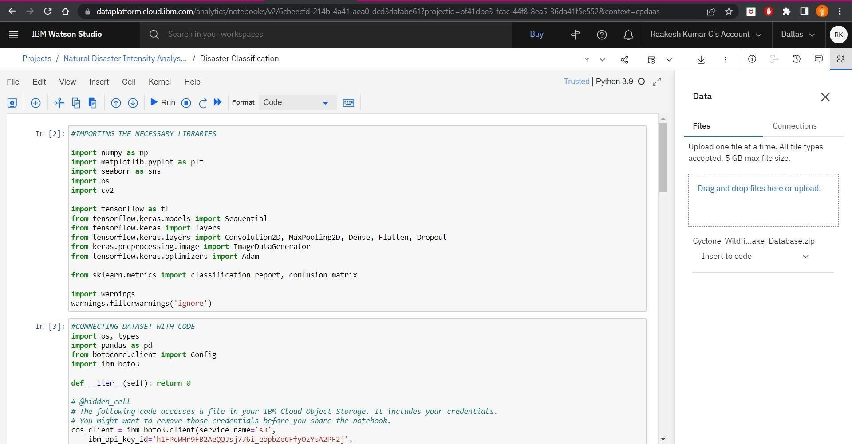

Sprint - I Milestones:

1. 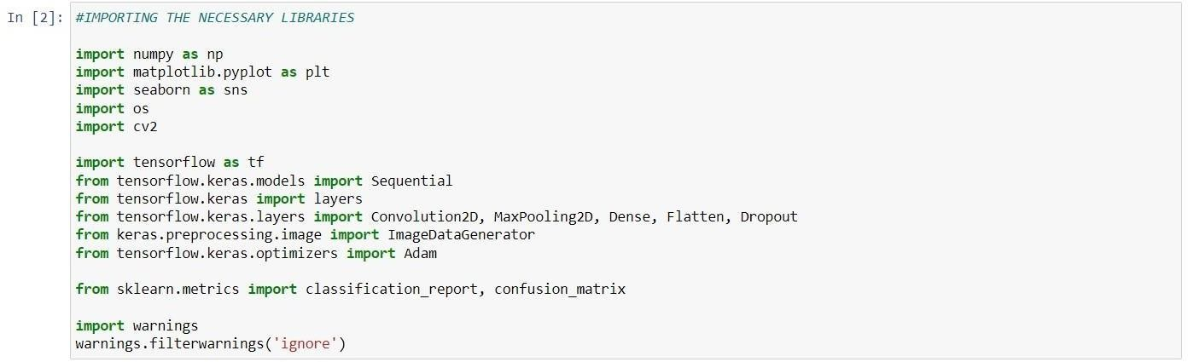**Import the Necessary Libraries**
2. 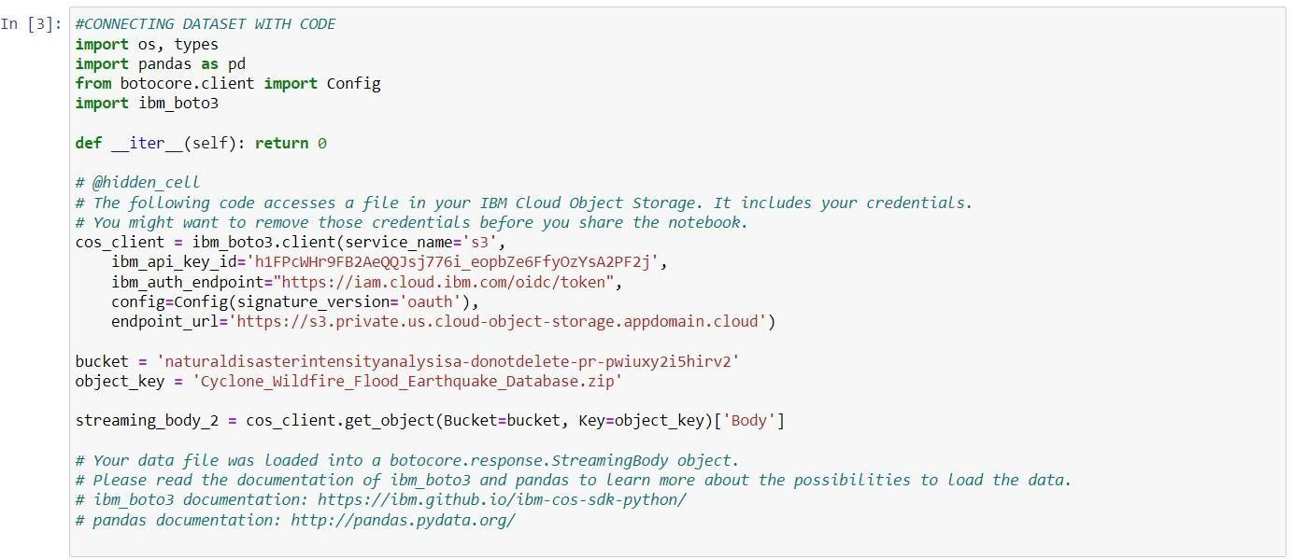**Upload and Connect Dataset with notebook**
3. **Extracting the Dataset using BytesIO unzip function**

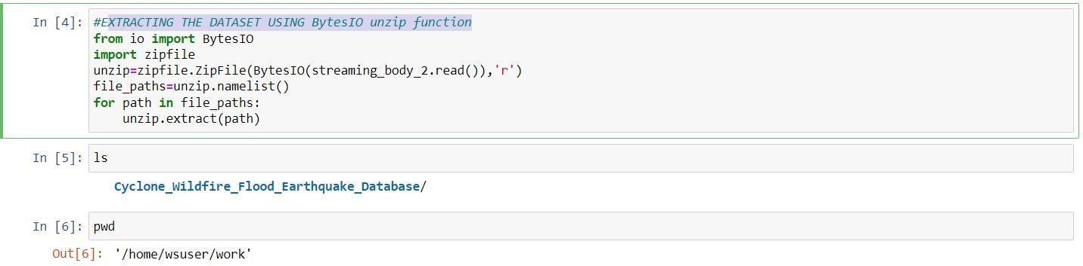

1. 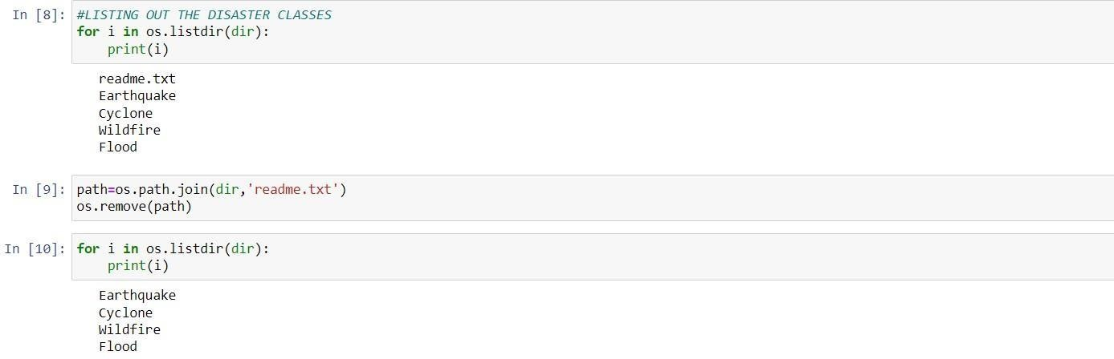**Listing out the Disaster Classes**
2. **Configuring ImageDataGenerator Class**



1. 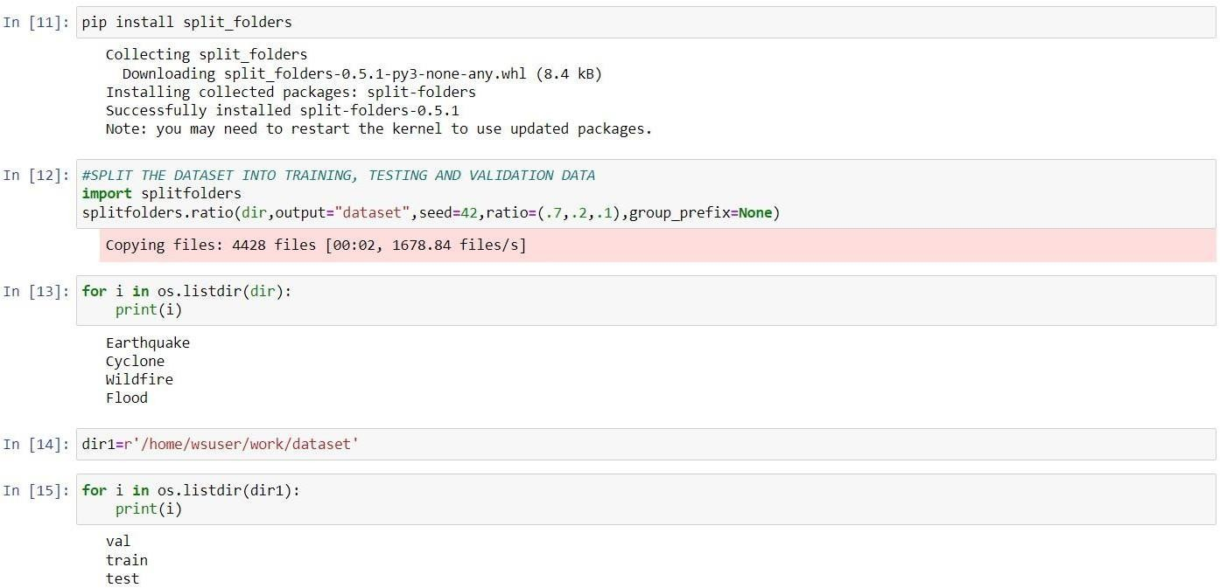**Split the dataset into training, testing, and validation data**
2. **Apply ImageDataGenerator Functionality to train set and test/validation set**

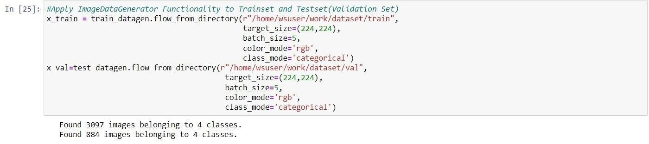

70% of the images are for training, 20% of Images are for validation and 10% remaining is for Testing